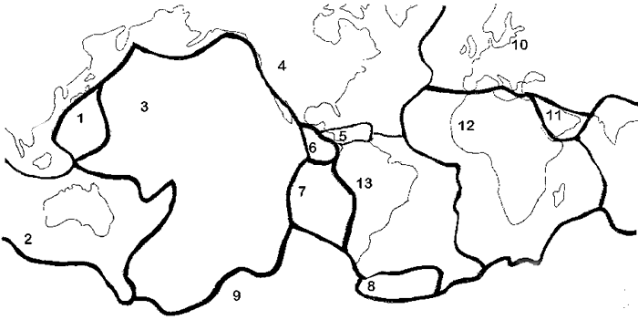

Plate Tectonics

Label the layers of the earth below:

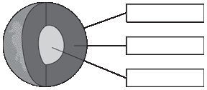
Plate tectonics is a geological theory that says the surface of Earth is broken into large plates. The size and position of the plates changes over time. The plates move in three ways:
- Convergence occurs when the plates move together and collide. This causes mountains to develop.
- Divergence occurs when the plates move away from each other. At that time, molten rock rises and cools and adds new material to the edge of the ocean crusts (ocean floor).
- Transform faults occur in the horizontal movement of plates against each other. This causes earthquakes.
Now you are to make a simulation of plate tectonics. Follow the directions below to make a box that looks like the one below. Cut a long very thin strip in the top and cut holes in both sides of the box.
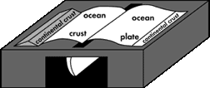
Step 1.
Take two sheets of blue paper to represent the oceanic plate. On both sheets place a triangular tube to represent the plate with an oceanic and continental crust. (Brown cardboard works well.)
Put the unattached sides of the papers through the slit so that only about half of the paper is showing. When the paper is pulled down, this represents the convergence of the plates. When the paper is pushed up, this represents the divergence of the plates.
Step 2.
Move only the sheet with the cardboard attached so that the cardboard comes to the edge of the slit. This represents the ocean plate disappearing beneath the edge of the continent. This is called subduction.
Step 3.
On the plain sheet of blue paper, attach another triangle so that this also has a continental and an oceanic crust. Now pull both sheets of blue paper from the bottom. If you do this carefully, one of the triangles will go on top of the other showing the development of mountains when convergence occurs.
Step 4.
If the layers are moved toward the sides of the box, the students can see the action of fault lines moving in an earthquake. This is called a transform fault.

Go to RLINK http://www.ucmp.berkeley.edu/geology/tectonics.html and see an animation of the plates moving into the position they currently hold.
Write a paragraph to explain what you discovered when you followed the steps listed above. Be sure to use the correct terminology. Also make a diagram showing one of the steps and what happened when you did what you were asked to do.
Draw diagram

